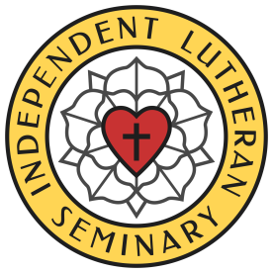
INDEPENDENT LUTHERAN SEMINARY
Upholding the Truth of Scripture and the Lutheran Confessions
1915 Carlson Drive, Klamath Falls, OR 97603
E-mail: indluthseminary@yahoo.com

SEMINARY APPLICATION
Date
Full Name
Full Address
Home Tel
Mobile Tel
E-mail

Name of Current Church | Church Location

X | Courses Applying For:
 | Orthodox Lutheran Theology
 | Homiletics
 | Pastoral Care /Ministry Direction

Please describe why you would like to take our courses:

